LAB # 01

INTRODUCTION

# OBJECTIVE

To become familiar with the Python Programming by using an Integrated Development Environment

# THEORY

**Programming**

The act of writing computer programs is called computer programming. A computer program is a sequence of instructions written using a computer programming language to perform specified tasks by the computer. There are a large number of programming languages that can be used to write computer programs, for example: Python, C, C++, Java, PHP, Perl, Ruby etc.

**Python Programming Language**

Python is a general-purpose, interpreted, object-oriented programming language. Python was created by Guido van Rossum in the Netherlands in 1990. Python has become a popular programming language widely used in industry and academia due to its simple, concise, and intuitive syntax and extensive library. Python is a general-purpose programming language. That means Python can be used to write code for any programming task. Python is now used in the Google search engine and in mission-critical projects at NASA etc. Python is interpreted, which means that Python code is translated and executed by an interpreter.

**Integrated Development Environment**

An Integrated Development Environment (IDE) is a software application that provides comprehensive facilities to computer programmers for software development. Typically, an IDE contains a code editor, a compiler or interpreter and a debugger that the developer accesses through a single graphical user interface (GUI). An IDE may be a standalone application, or it may be included as part of one or more existing and compatible applications. IDEs are also available online that can be accessed through a web browser.

Using an IDE will save a lot of time and effort in writing a program. However, one should be careful of some of the pitfalls of using an IDE as it may not be ideal for everyone and might not be suitable in every situation. Some IDEs are very complicated to use and may consume a lot of resources.

Many IDEs support Python Programming Language. Some of the popular IDEs are listed below.

**Standalone IDEs:**

* **Microsoft Visual Studio Code**

https://code.visualstudio.com/

* **Eclipse**

https://www.eclipse.org/downloads

* **NetBeans**

https://netbeans.org/downloads/

* **Thonny**

<https://thonny.org/>

* **Anaconda**

<https://www.anaconda.com/distribution/>

**Online IDEs:**

* **Ideone**

https://ideone.com/

* **Online GDB**

<https://www.onlinegdb.com/online_python_debugger>

**Creating a Python program file with Thonny**

Thonny is a free Python Integrated Development Environment (IDE) that is designed for beginners. Thonny comes with Python 3.7 built in, so just one simple installer is needed to get started.

**Step#1:** Go to [https://thonny.org](https://thonny.org/)

**Step#2:** Download the version for Windows and wait a few seconds while it downloads.

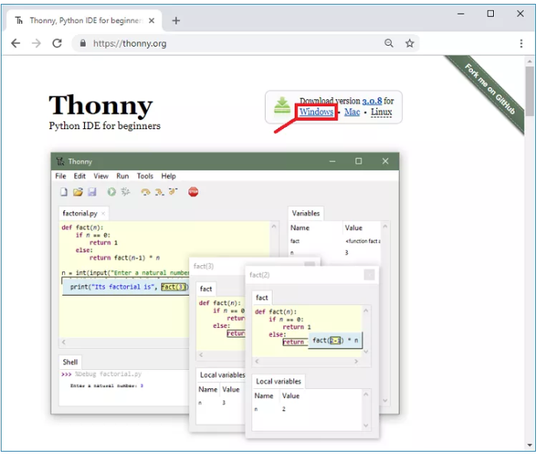

**Step#3:**Run the *.exe* file.

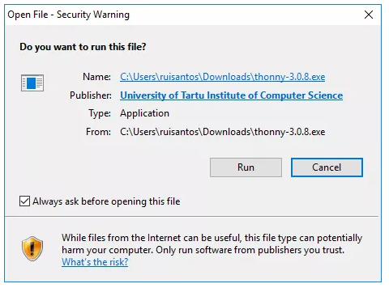

**Step#4:** Follow the installation wizard to complete the installation process and just click "Next".

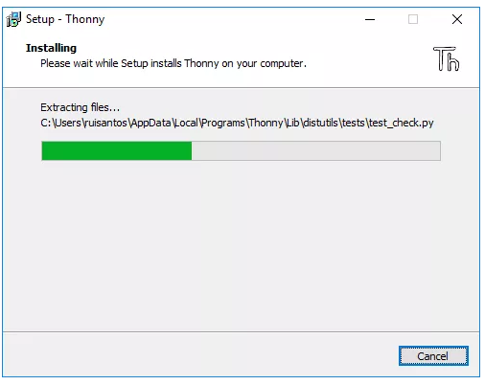

**Step#5:** After completing the installation, open Thonny IDE. A window as shown in the following figure should open.

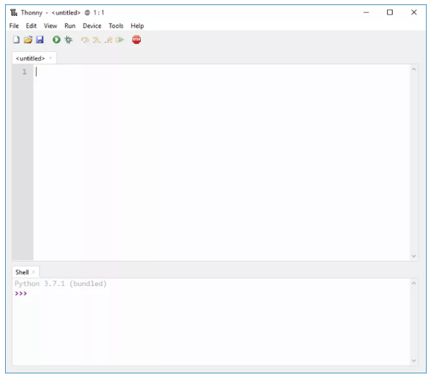

### A simple Python program

Following is a simple Python program.

#Description: Display two messages

'''Writes the words "Hello, World! and Python is fun" on the screen'''

print("Hello, World! \n Python is fun")

print("Hello, World! \n Python is fun") instructs the computer to print on the screen the string of characters enclosed by the quotation marks.

\n is an escape sequence that means newline. It causes the cursor to position to the beginning of the next line on the screen.

pound sign (#) is a comment on a line, called a line comment, or enclosed between three consecutive single quotation marks (''') on one or several lines, called a paragraph comment.

Python programs are case sensitive. It would be wrong, for example, to replace print in the program with Print. Several special characters can be seen (#, ", ()) in the program. They are used in almost every program. Table 1.1 summarizes their uses.

Table1.1: Special characters

|  |  |  |
| --- | --- | --- |
| Character | Name | Description |
| ( ) | Opening and closing parentheses | Used with function |
| # | Pound sign or comment | Precedes a comment line |
| “ “ | Opening and closing quotation marks | Encloses a string (i.e.,sequence of characters) |
| ‘‘’ ‘’’ | Paragraph comments | Encloses a paragraph comment |

**Build and Run a Python Program**

**Step#1:** Go to **File** > New. Then save the **file** with .py extension.

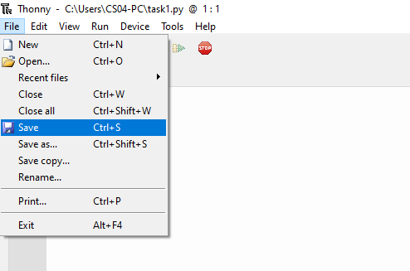

**Step#2:** Write your code in .py file.

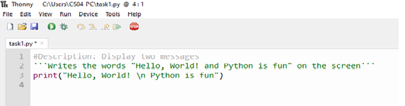

**Step#3:** Then Go to **Run** > **Run** current **script** or simply click F5 to **run** it

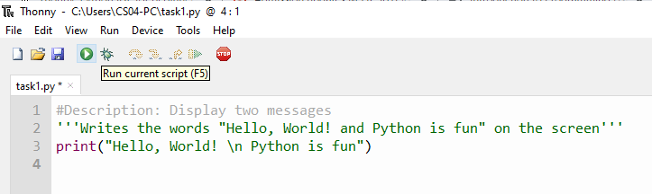

The output would be displayed in a separate window.

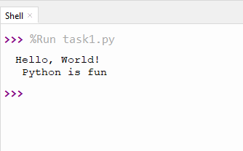

**EXERCISE**

1. **Create a file named lab1.py. Write the following code in the file. Execute it and show the output.** (You can use the Snipping Tool to take a snapshot of your output window).
2. Code:

|  |
| --- |
| # My first program  print("\nWelcome in the world of programming!") |

Output:

|  |
| --- |
|  |

1. Code:

|  |
| --- |
| #My second program  print("Welcome in the\n ")  print("world of programming! ") |

Output:

|  |
| --- |
|  |

1. **Write a program in Python language that prints your bio-data on the screen. Show your program and its output**